**RAJALAKSHMI ENGINEERING COLLEGE**

**RAJALAKSHMI NAGAR, THANDALAM – 602 105**



|  |
| --- |
| **CS23A34**  **USER INTERFACE AND DESIGN LAB** |
| **Laboratory Observation Notebook** |

**Name :** VIKNESHKUMAR MN

**Year/Branch/Section :** II/CSE/D **Register No. :** 230701382

**Semester :** IV

**Academic Year:** 2024-25

# Ex. No.: 7.a

**Register No.: 230701382 Name: Vikneshkumar MN**

**Develop low-fidelity paper prototypes for a banking app and convert them into digital wireframes using Pencil Project**

# AIM:

The aim is to develop low-fidelity paper prototypes for a banking app and convert them into digital wireframes with Pencil Project.

# PROCEDURE:

**Tool Link:** [**https://pencil.evolus.vn/**](https://pencil.evolus.vn/)

# Step 1: Create Low-Fidelity Paper Prototypes

1. **Define the Purpose and Features**:
   * Identify the core features of the banking app (e.g., login, account balance, transfers, bill payments).

# Sketch Basic Layouts:

* + Use plain paper and pencils to sketch basic screens.
  + Focus on primary elements like buttons, menus, and forms.

# Iterate and Refine:

* + Get feedback from users or stakeholders.
  + Iterate on your sketches to improve clarity and functionality.

# Step 2: Convert Paper Prototypes to Digital Wireframes Using Pencil Project

1. **Install Pencil Project**:
   * Download and install Pencil Project from the official website.

# Create a New Document:

* + Open Pencil Project and create a new document.

# Add Screens:

* + Click on the "Add Page" button to create different screens (e.g., Login, Dashboard, Transfer).

# Use Stencils and Shapes:

* + Use the built-in stencils and shapes to create UI elements.
  + Drag and drop elements like buttons, text fields, and icons onto your canvas.

# Organize and Align:

* + Arrange and align the elements to match your paper prototype.
  + Ensure that the design is user-friendly and intuitive.

# Link Screens:

* + Use connectors to link different screens together.
  + Create navigation flows to show how users will interact with the app. 7.

# Add Annotations:

* + Include annotations to explain the functionality of different elements.

# 8. Export Your Wireframes:

* Once satisfied with your digital wireframes, export them in your preferred format (e.g., PNG, PDF).

# OUTPUT:

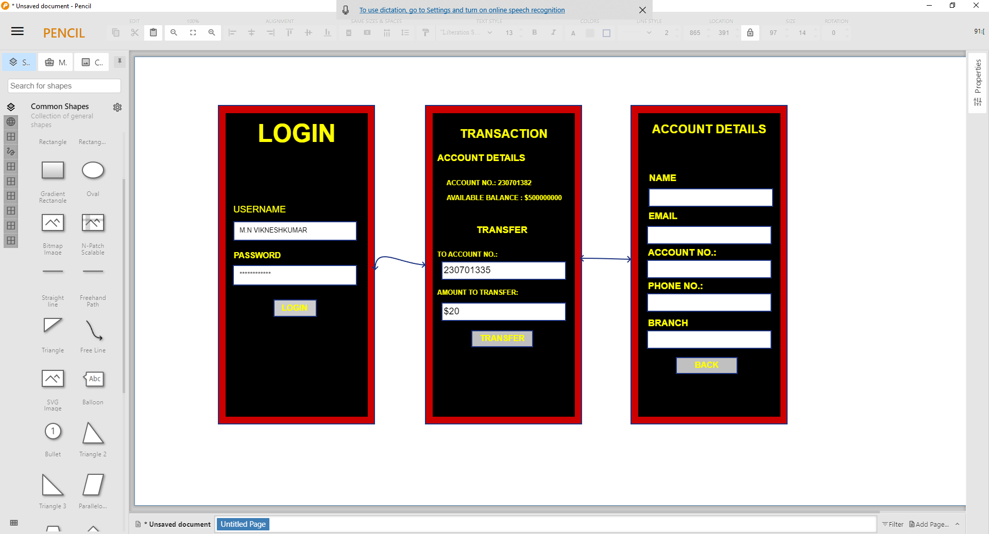

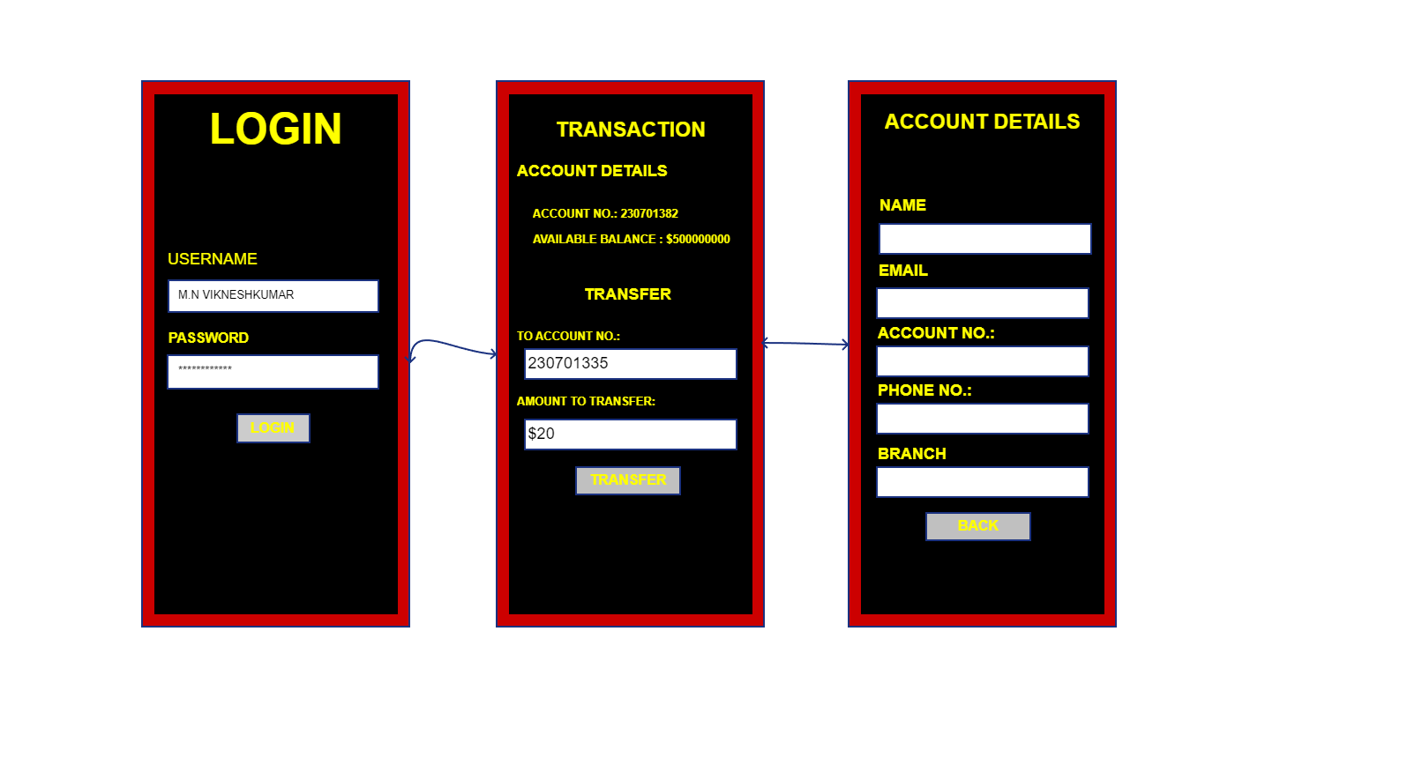

**RESULT:**

Hence we have developed low-fidelity paper prototypes for a banking app and converted them into digital wireframes with Pencil Project.